Complete tasks, related to training 40:
1. Locate css and xpath selectors for following elements in yandex.com (2 variants – css and xpath – for each, do NOT add them to project, just create word document with these locators):
Start page:
- Search input
Xpath - //input[@id=“text”] CSS - #text
- Find button
Xpath - //button[@type= “submit”] CSS - button[type=submit]

Email page (light version)
- Write email button 2 elments received
Xpath - //a[@href="/lite/compose/retpath=%2F"]/i
CSS - .b-toolbar__i span.b-toolbar__col:first-child
Xpath - //a[@role = “button”] CSS – a.b-toolbar__but
- Logout link
Xpath - //a[contains(., “Выход”)] - different locations results to language changes and test failing
CSS = a[href=“https://passport.yandex.by/passport?mode=logout&yu=3285238721648712643&retpath=https%3A%2F%2Fyandex.by”]
XPath - //a[@class='b-header__link b-header__link_exit']
CSS - .b-header__link.b-header__link_exit
- Settings link
Xpath - //a[contains(., “Настройка)] CSS - a[href = “/lite/setup”]
- 1 locator for all 5 elements: Inbox, Sent, Deleted, Spam and Draft links
Xpath - //span[contains(@class, “b-folders__folder__name”)]
CSS – span.b-folders__folder__name
- 1 locator for all 4 elements: Inbox, Deleted, Spam and Draft links – тут здаюсь, помогай)
Xpath - //div[@class=“b-folders”]
CSS - .b-folders
Xpath - //div[@class='b-folders']/descendant::a[position()>0 and position()<6 and position() !=2]
CSS - .b-folders div[role='navigation']:first-child

New email page

- To input
Xpath - //input[@name =“to”] CSS – input[name=to]
- Topic input
Xpath - //input[@name =“subj”] CSS – input[name=subj]
- Find button
Xpath - //input[@name=“search”] CSS – input[name=search]
- Add multiple attachments
Xpath - //button[@value=“multy-att”] CSS – button.b-compose__more-attach__link
- 1 locator for all 3 elements: Send, Save and Cancel inputs
Xpath - //input[contains(@class, “b-form-button”)]
CSS – input.b-form-button
- Update locator (just add any code after it, but initial part must be presented as beginning of locator) “.b-compose__file | “//input[@class=“b-compose__file”]” to grab all 3 elements: Send, Save and Cancel inputs
Xpath - //input[@class=“b-compose__file”]/following-sibling::input
CSS - .b-compose__file ~ .b-form-button
- Update locator (just add any code after it, but initial part must be presented as beginning of locator) “button[name=“nosend”] | “//button[@name=nosend]” to grab all 3 elements: send, Save and Cancel inputs
Xpath - //button[@name=“nosend”]/following::input[@type = “submit”]
Unable to create locator using CSSXpath only. Update locator (just add any code after it, but initial part must be presented as beginning of locator) “//input[contains(@class, “b-compose__cancel”)] to grab all 2 elements: Send and Save inputs

Xpath - //input[contains[@class, “b-compose__cancel”)]/preceding-sibling::input[@type =
Submit”]
- Update locator (just add any code after it, but initial part must be presented as beginning of locator) “.b-buttons>input” | “//div[@class=“b-buttons”/input” to grab all elements: Choose Files, Save and Cancel inputs
XPath - //div[@class=“b-buttons”]/input[@name=“att” or @name=“nosend” or @name=“cancel”]
CSS - .b-buttons>input:not(.b-form-button.b-compose__send)

Send page
- Css only. Locator to get even links to topics starting from 4th email
Css – div[class=b-messages] div:nth-child(n+4)
Css - .b-messages .b-messages__message:nth-child(n+4)
Only topic links are our goal

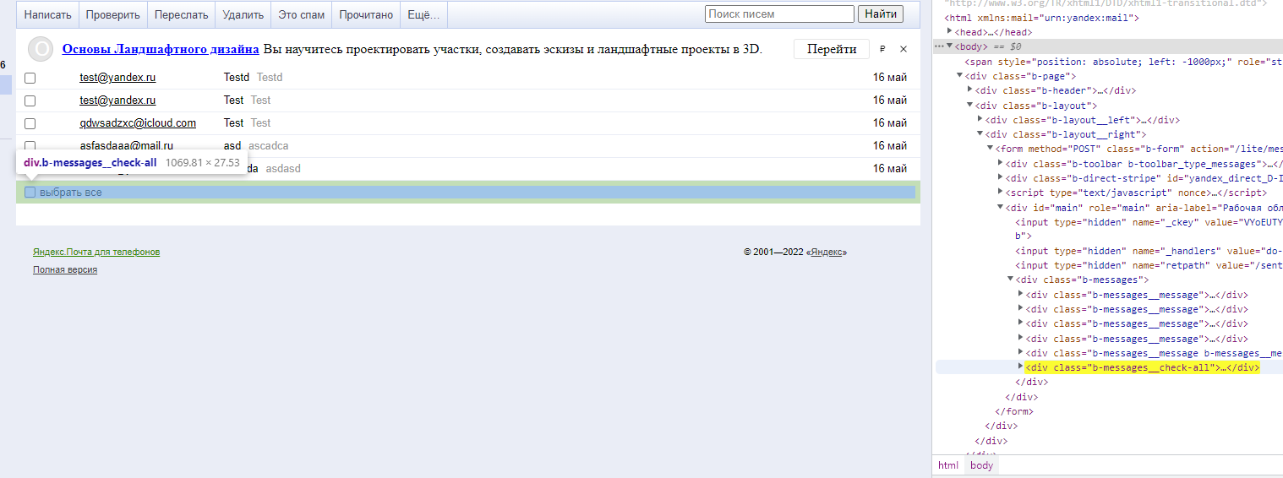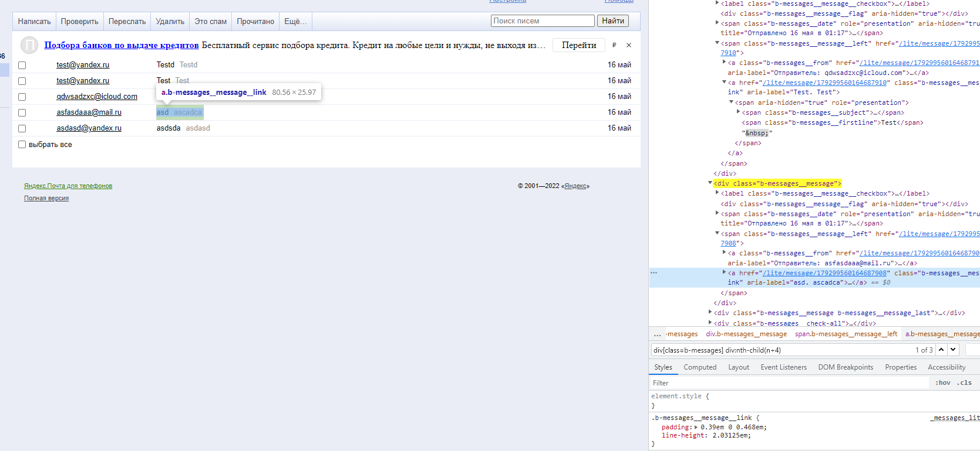

- Xpath only. Locator to get all links to topics starting from 2nd email
Xpath - //div[@class = “b-messages”]/child::div[position()>2]
Xpath - //div[contains(@class,"b-messages__message")][position()>2]
The same

